**Narrative # 1**  
  
**Concert:**  
Soave Sia Il Vento  
  
**With artists:**  
Radio Kamerorkest  
Sante, Sophia van  
Berg, Maurits van den  
Ameling, Elly  
Derksen, Jan  
  
  
**With creator(s):**  
Mozart, Wolfgang Amadeus  
  
  
**Has genre:**  
klassieke muziek  
theatermuziek  
vocaal - twee of meer zangstemmen met orkest  
  
  
The most important entity seems to be **Mozart, Wolfgang Amadeus** which was also was part of:  
  
**Concert:**  
Programma Radio Kamerorkest - Nederlands Kamerorkest - Bour, Ernest - Vries, Han de - Werthen, Rudolf - Quant, Abbie de - Meyer, Hans  
  
**With artists:**  
Radio Kamerorkest  
Nederlands Kamerorkest  
Bour, Ernest  
Quant, Abbie de  
Vries, Han de (musicus)  
Werthen, Rudolf  
Meyer, Hans  
  
  
**With creator(s):**  
Mozart, Wolfgang Amadeus  
Salieri, Antonio  
Mysliveček, Josef  
  
  
**Year of publication:**  
1984  
  
  
**Location it was created:**  
Amsterdam  
  
  
**Provider organization:**  
VOO  
  
  
The most important entity seems to be **Radio Kamerorkest** which was also was part of:  
  
**Concert:**  
Programma Radio Kamerorkest - Carewe, John  
  
**With artists:**  
Radio Kamerorkest  
  
  
**Year of publication:**  
1984  
  
  
**Has genre:**  
klassieke muziek  
instrumentaal - orkest  
  
  
**Provider organization:**  
NCRV  
  
  
The most important entity seems to be **1984** which was also was part of:  
  
**Concert:**  
Programma Concertgebouworkest - Haitink, Bernard - Brautigam, Ronald  
  
**With artists:**  
Concertgebouworkest  
Haitink, Bernard  
Brautigam, Ronald  
  
  
**With creator(s):**  
Mozart, Wolfgang Amadeus  
Beethoven, Ludwig van  
Prokofjev, Sergei  
  
  
**Year of publication:**  
1984  
  
  
**Location it was created:**  
Amsterdam  
  
  
**Provider organization:**  
WERELDOMROEP  
  
  
The most important entity seems to be **Amsterdam**

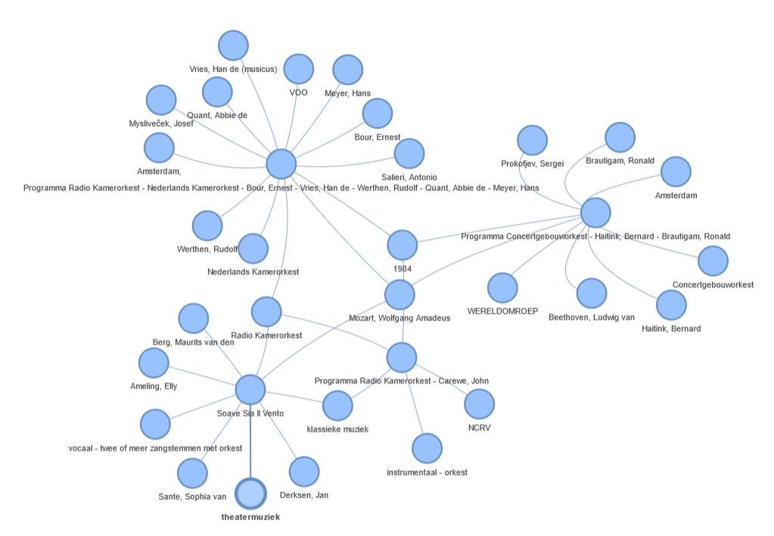

**Fig 4.3.2: Narrative # 1 Visualization**

**Narrative #2**  
**Concert:**  
Programma Radio Kamerorkest - Koopman, Ton  
  
**With artists:**  
Koopman, Ton  
Radio Kamerorkest  
  
  
**Year of publication:**  
1984  
  
  
**Has genre:**  
klassieke muziek  
religieuze muziek  
instrumentaal - orkest  
  
  
**Location it was created:**  
Amsterdam  
  
  
**Provider organization:**  
VARA  
  
  
The most important entity seems to be **instrumentaal - orkest** which was also was part of:  
  
**Concert:**  
Programma Radio Kamerorkest - Carewe, John  
  
**With artists:**  
Radio Kamerorkest  
  
  
**Year of publication:**  
1984  
  
  
**Has genre:**  
klassieke muziek  
instrumentaal - orkest  
  
  
**Location it was created:**  
Amsterdam  
  
  
**Provider organization:**  
VPRO  
  
  
The most important entity seems to be **VPRO** which was also was part of:  
  
**Concert:**  
Programma Radio Kamerorkest - Carewe, John  
  
**With artists:**  
Radio Kamerorkest  
  
  
**Year of publication:**  
1984  
  
  
**Has genre:**  
klassieke muziek  
instrumentaal - orkest  
  
  
**Provider organization:**  
VPRO  
  
  
The most important entity seems to be **Radio Kamerorkest** which was also was part of:  
  
**Concert:**  
Programma Radio Kamerorkest - Zender, Hans  
  
**With artists:**  
Radio Kamerorkest  
Zender, Hans  
  
  
**Year of publication:**  
1984  
  
  
**Has genre:**  
klassieke muziek  
instrumentaal - orkest  
  
  
**Provider organization:**  
NCRV  
  
  
The most important entity seems to be **Zender, Hans**

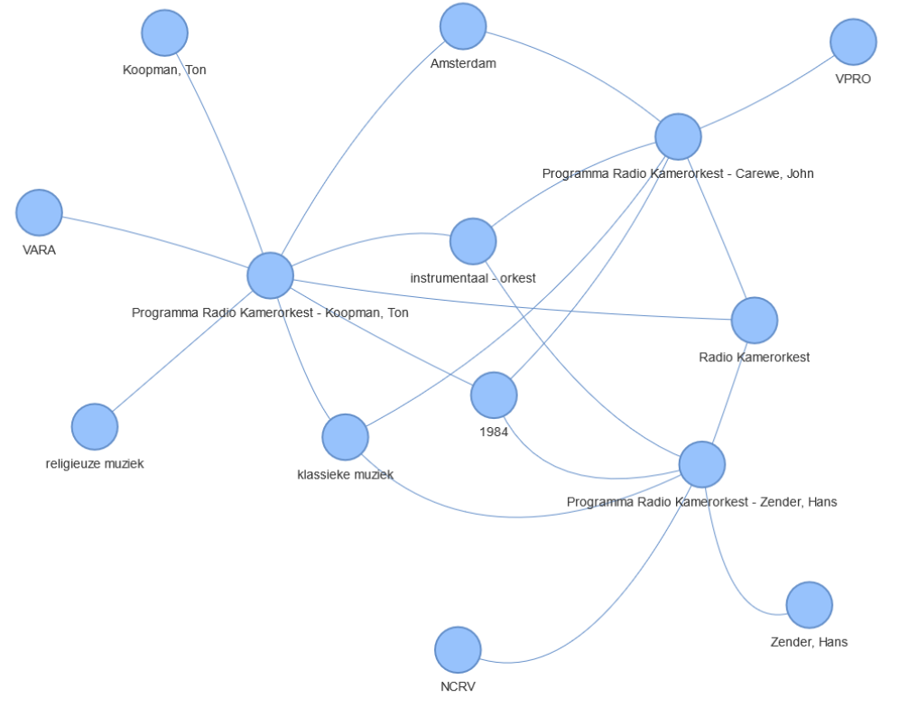

**Fig 4.3.3: Narrative # 2 Visualization**

**Narrative # 3**

**Concert:**  
Mis in C gr.t. (KV.317)  
  
**With artists:**  
Koopman, Ton  
Radio KamerorkestGroot Omroepkoor  
Mertens, Klaus  
Magnus, Elisabeth von  
Trost, Rainer  
Rey, Isabel  
  
  
**With creator(s):**  
Mozart, Wolfgang Amadeus  
  
  
**Has genre:**  
klassieke muziek  
religieuze muziek  
vocaal - solo of soli met koor en orkest  
  
  
**Location it was created:**  
Amsterdam  
  
  
The most important entity seems to be **Groot Omroepkoor** which was also was part of:  
  
**Concert:**  
Programma Frimmer, Monika - Dykstra, Hebe - Berne, Harry van - Heynsbergen, Henk van - Vera, Ana Maria - Groot Omroepkoor - Radio Kamerorkest - Oestman, Arnold  
  
**With artists:**  
Radio Kamerorkest  
Groot Omroepkoor  
Oestman, Arnold  
Heijnsbergen, Henk van  
Dijkstra, Hebe  
Berne, Harry van  
Vera, Ana Maria  
Frimmer, Monika  
  
  
**With creator(s):**  
Mozart, Wolfgang Amadeus  
  
  
**Year of publication:**  
1991  
  
  
**Location it was created:**  
AT&  
  
  
**Provider organization:**  
NCRV  
  
  
The most important entity seems to be **Oestman, Arnold** which was also was part of:  
  
**Concert:**  
Fluit-harpconcert in C gr.t. (KV.299)  
  
**With artists:**  
Radio Kamerorkest  
Quant, Abbie de  
Smits, Manja  
Oestman, Arnold  
  
  
**With creator(s):**  
Mozart, Wolfgang Amadeus  
  
  
**Has genre:**  
klassieke muziek  
instrumentaal - orkest  
  
  
**Location it was created:**  
Amsterdam  
  
  
The most important entity seems to be **Quant, Abbie de** which was also was part of:  
  
**Concert:**  
Fluit-harpconcert in C gr.t. (KV.299)  
  
**With artists:**  
Radio Kamerorkest  
Kieft, Roland  
Witsenburg, Edward  
Quant, Abbie de  
  
  
**With creator(s):**  
Mozart, Wolfgang Amadeus  
  
  
**Has genre:**  
klassieke muziek  
instrumentaal - orkest  
  
  
**Location it was created:**  
Utrecht  
  
  
The most important entity seems to be **Kieft, Roland**

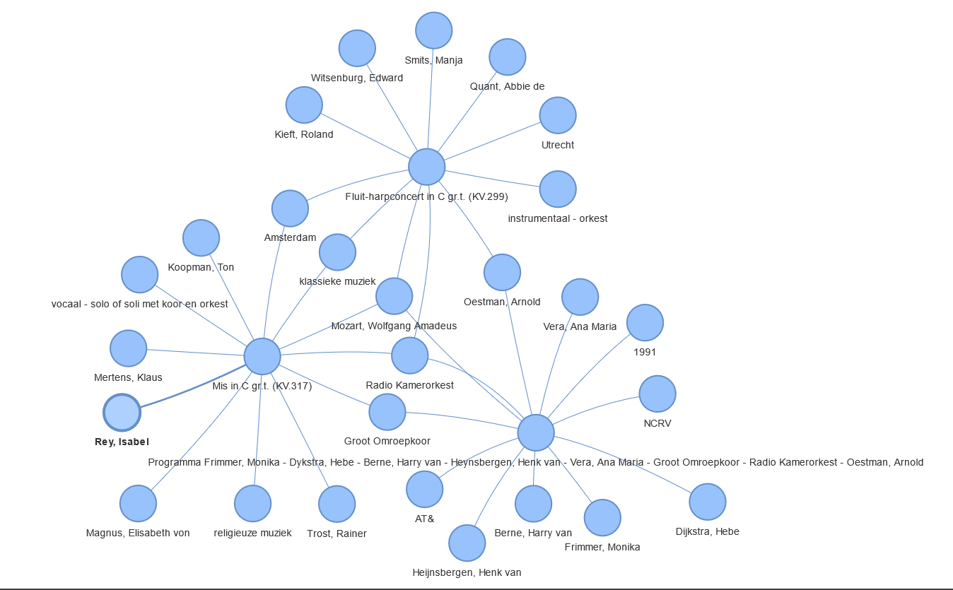

**Fig 4.3.4: Narrative # 3 Visualization**

**Narrative # 4**

**Concert :**  
Programma Blochwitz, Hans Peter - Mills, Erie - Montgomery, Kenneth - Montgomery, Kenneth - Pierotti, Raquel - Gale, Elisabeth - Vink, Elena - Meens, Hein - Omroep Kamerkoor - Klein Omroepkoor - Gritton, Robin - Radio Kamerorkest  
  
**With artists:**  
Radio Kamerorkest  
Omroep Kamerkoor  
Montgomery, Kenneth  
Klein Omroepkoor  
Meens, Hein  
Gritton, Robin  
Mills, Erie  
Pierotti, Raquel  
Blochwitz, Hans Peter  
Vink, Elena  
Gale, Elisabeth  
  
  
**Year of publication:**  
1984  
  
  
**Has genre:**  
klassieke muziek  
vocaal - solo of soli met koor en orkest  
theatermuziek  
  
  
**Location it was created:**  
Amsterdam  
  
  
**Provider organization:**  
WERELDOMROEP  
VARA  
  
  
The most important entity seems to be **Montgomery, Kenneth** which was also was part of:  
  
**Concert:**  
Programma Koten, Frank van - Jeurissen, Herman - Lier, Sonja van - Nyhuis, Annelies - Robert, Geraint - Groot Omroepkoor - Radio Kamerorkest - Montgomery, Kenneth  
  
**With artists:**  
Radio Kamerorkest  
Groot Omroepkoor  
Montgomery, Kenneth  
Lier, Sonja van  
Koten, Frank van  
Jeurissen, Herman  
  
  
**With creator(s):**  
Mozart, Wolfgang Amadeus  
Haydn, Joseph  
Bree, Johannes van  
  
  
**Year of publication:**  
1990  
  
  
**Location it was created:**  
VARA  
  
  
**Provider organization:**  
NCRV  
  
  
The most important entity seems to be **Haydn, Joseph** which was also was part of:  
  
**Concert:**  
Programma Rotterdams Ph.Orkest - Conlon, James - Merwe Hoorn, Martin v.d.  
  
**With artists:**  
Rotterdams Philharmonisch Orkest  
Conlon, James  
  
 **With creator(s):**  
Mozart, Wolfgang Amadeus  
Haydn, Joseph  
Gluck, Christoph Willibald von  
  
  
**Year of publication:**  
1984  
  
  
**Location it was created:**  
De  
  
  
**Provider organization:**  
NOS  
  
  
The most important entity seems to be **Gluck, Christoph Willibald von** which was also was part of:  
 **Concert:**  
Programma Bommel Kwartet - Bilitis Ensemble  
  
**With artists:**  
Bommelkwartet  
  
  
**With creator(s):**  
Telemann, Georg Philipp  
Haydn, Joseph  
Berlioz, Hector  
Jolivet, André  
Saint-Saëns, Camille  
Falla, Manuel de  
Bruch, Max  
Gluck, Christoph Willibald von  
Meijering, Chiel  
Paganini, Niccolò  
Zelenka, Jan Dismas  
  
 **Year of publication:**  
1984  
  
  
**Location it was created:**  
VARA  
  
 **Provider organization:**  
VOO  
  
  
The most important entity seems to be **Telemann, Georg**

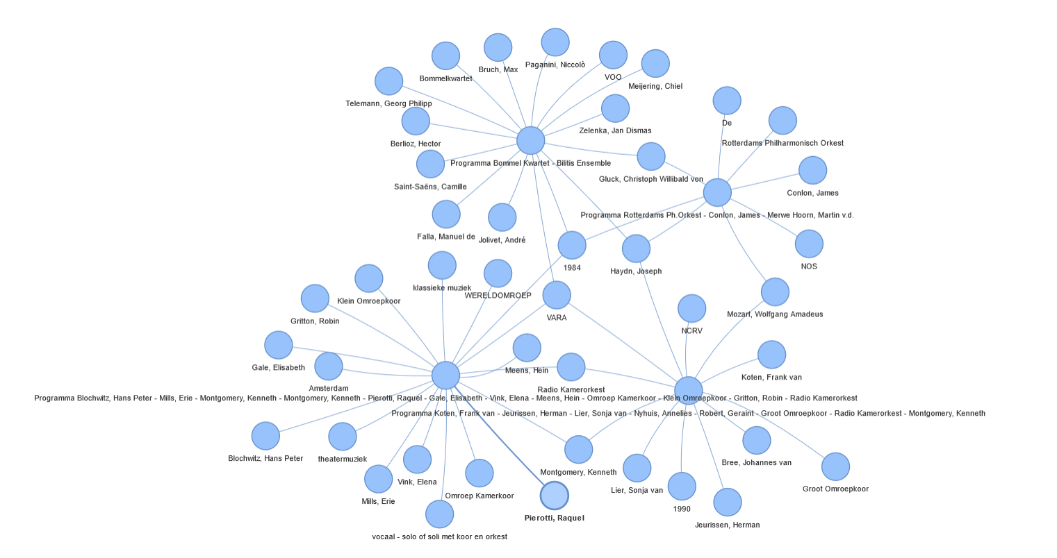

**Fig 4.3.5: Narrative # 4 Visualization**

**Narrative # 5**

**Concert:**  
Vioolconcert No.4 In D Gr.t. (kv.218)  
  
**With artists:**  
Radio Kamerorkest  
Driehuys, Leo  
Bor, Christiaan  
  
 **With creator(s):**  
Mozart, Wolfgang Amadeus  
  
  
**Has genre:**  
klassieke muziek  
instrumentaal - orkest  
  
  
The most important entity seems to be **Driehuys, Leo** which was also was part of:  
 **Concert:**  
Pianoconcert No.19 In F Gr.t. (kv.459)  
  
**With artists:**  
Radio Kamerorkest  
Driehuys, Leo  
Andersen, Diane  
  
  
**With creator(s):**  
Mozart, Wolfgang Amadeus  
  
 **Has genre:**  
klassieke muziek  
instrumentaal - orkest  
  
  
The most important entity seems to be **Andersen, Diane** which was also was part of:  
  
**Concert:**  
Programma Andersen, Diane - Radio Filh.Orkest - Fournet, Jean  
  
**With artists:**  
Fournet, Jean  
Andersen, Diane  
  
  
**With creator(s):**  
Schoonhoven, Frank  
  
  
**Year of publication:**  
1986  
  
  
**Has genre:**  
klassieke muziek  
instrumentaal - orkest  
  
  
**Provider organization:**  
NCRV  
  
  
The most important entity seems to be **Fournet, Jean** which was also was part of:  
  
**Concert:**  
Ouverture  
  
**With artists:**  
Radio Kamerorkest  
Fournet, Jean  
  
  
**With creator(s):**  
Mozart, Wolfgang Amadeus  
  
  
**Has genre:**  
klassieke muziek  
theatermuziek  
instrumentaal - orkest  
  
  
**Location it was created:**  
Amsterdam  
  
  
The most important entity seems to be **theatermuziek**

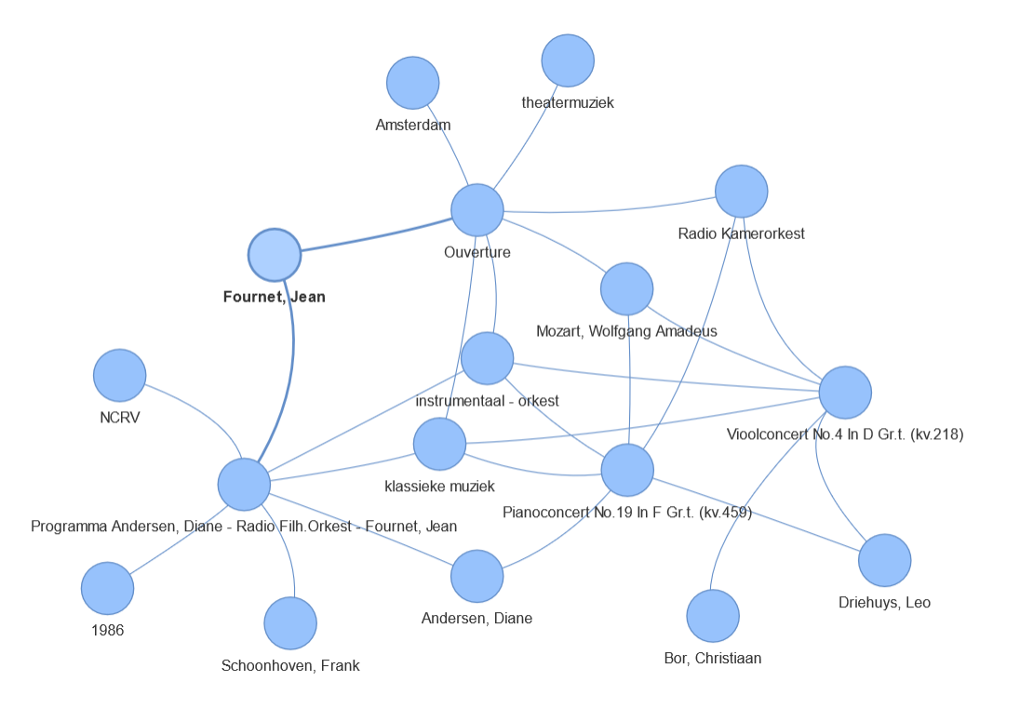

**Fig 4.3.6: Narrative # 5 Visualization**